From: Michael Heaps, Horrocks Engineers
To: Myron Lee, Director, Dixie MPO
Subject: RE: Travel Demand Modeling detail

I’ve had a chance to look at the two proposed projects on 100 S & 700 S that add a center-lane under I-15. The purpose of this email is to summarize my findings.

Currently both roadways carry roughly 22,000 trips per day under I-15. Based on typical planning level capacities (see attachment for details) a 4-lane section of roadway in a suburban environment can accommodate roughly 23,000 to 29,000 vehicles per day (depending on its functional classification) and operate at LOS D. Based on typical capacities both streets would be expected to operate at LOS D or better under current conditions.

In 2040 traffic on 100 S is expected to increase to 31,000 vpd and 700 S is expected to increase to 28,000 vpd. With the increases in traffic it is likely both 100 S and 700 S would operate at LOS E or worse in 2040. Widening the cross-section to five-lanes increases the capacity to between 25,000-31,000 vpd by allowing left-turning vehicles to remove themselves from the main flow of traffic while waiting to turn. From a basic capacity analysis widening both sections appear warranted.

From an operational standpoint it’s preferred that center turn-lanes are provided on all collector/arterial roadways that have accesses, as is the case with most of 100 S/700 S. A high number of left-turning vehicles on a 4-lane section could basically convert the 4-lane roadway to 2-lanes as the inside lanes are used as storage for left-turning vehicles.

All of the internal gridded streets in St. George, including 100 South and 700 South, were in place and operational by the time I-15 intruded through the community in the early 70’s. Because of this, I-15 forced the closure of many of these streets so they could not connect to the east. The only exceptions were 100 South and 700 South. State of Utah transportation planners at the time provided bridges at these 2 locations with the thinking that property could be more easily accessed on both sides, but they didn’t plan on designing bridges to accommodate 5-lane minor arterials. Washington City experienced this same issue with their Main Street crossing. With the widening of 100 South and 700 South to 2 lanes in both directions, the roads used all of the width available which did not include room for center turn lanes.

Although no direct access exists along the sections that are proposed to be widened there are accesses nearby that would be expected to use the center lane. Currently on 100 S there are three accesses adjacent to I-15 that have limited distance (for deceleration and storage) for vehicles attempting to turn left from 100 S into each access. There are two accesses on 100 S that have limited distance for vehicles attempting to use the center turn-lane to complete a two-stage gap acceptance maneuver in which the vehicle first turns into the center lane, waits for a gap in traffic, and then merges to complete the maneuver. In the eastbound direction, there is an abrupt taper that shifts lanes to the north in order to squeeze the lanes under the bridge. Adding to this lane shift is the presence of a depressed drain inlet in the gutter that impacts drivers in the outside lane while steering through the shift. This taper, and to a lesser extent, the drain, introduces a possible risk for drivers that may be distracted or inexperienced. See the following figure for details:

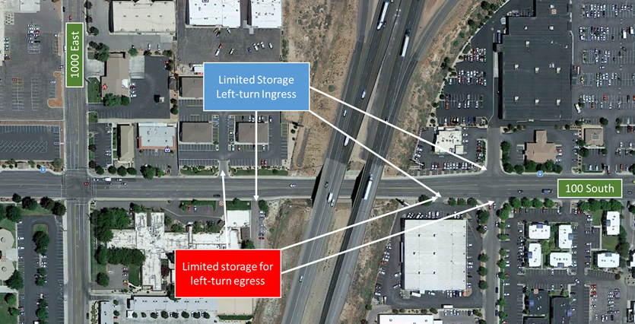

Often when completing a two-stage left-turn movement drivers will use the center lane to accelerate and merge into traffic. Based upon discussion with the city some drivers are unaware of the elimination of the center lane under the freeway and are forced to merge unexpectedly. The city reports crash clusters along these sections of roadway.

At 700 S there doesn’t appear to be as many deficiencies caused by not having a center turn-lane under I-15. Currently on 700 S there is one access adjacent to I-15 that has limited distance for vehicles attempting to turn left from 700 S into the access. There is also one access on 700 S that has limited distance for vehicles attempting to use the center turn-lane to complete a two-stage gap acceptance maneuver. See the following figure for details:

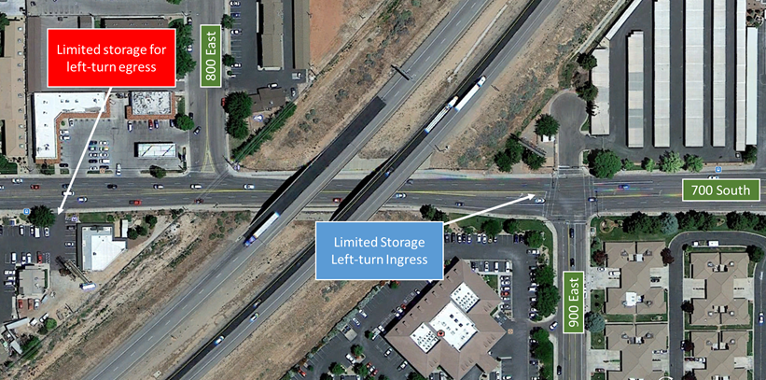

The signal at 900 E and the right-in/right-out at 800 E helps to limit the impacts of the 4-lane section.

Based on operations I would recommend the 100 S be widened. The 700 S location would also benefit from a center-lane across I-15 but to a lesser degree than 100 S.

Both 100 S and 700 S would be considered “regionally significant”. I would recommend the 100 S widening be added to the RTP as a phase I project based on operational needs and 700 S widening be added as a phase III project based on capacity.

Let me know if you have any questions.

Thanks,

Mike

